|  |
| --- |
| Project Title DVD Rental Management System |
| Version Number: 2.0 **Change History**   |  |  |  | | --- | --- | --- | | **Date** | **Author** | **Comments** | | **16/02/13** | **Paul** | **Summary, assumptions and dependencies added** | | **23/02/12** | **Paul** | **Added Designs and Diagrams of our project** | |  |  |  | |  |  |  | |
| Summary Design a system that has two levels, Administrators: administrators are allowed perform all system operations and Ordinary users: are only allowed perform ordinary user tasks. Administrators are required to be able to perform the following tasks, Entering the details of a new DVD, Editing the details of any DVD, Deleting a DVD, Adding the details of a customer, Editing the details of any customer, Deleting a customer, Viewing a list of all of the DVD’s that are currently in stock, Viewing a list of all of the DVD’s that are currently overdue. Ordinary users are required to be able to Search for a DVD given a portion of the title, Searching for a user given a portion of their name, Allowing a customer rent a DVD, Allowing a customer return a DVD |

Assumptions & Dependencies

**Language used to develop: Java**

* Extensive knowledge in the language and GUI development in swing.
* Portability over any Operating Systems.
* Graphics libraries: Swing and AWT.
* Disadvantages: Leaked in security in recent release

**Alternatives: Visual Basic.net**

**Advantages:**

* Easy to use, drop and drag development.
* Libraries maintained and updated by Microsoft.

**Disadvantages:**

* Not open source.
* Visual Studio not free, development Licence needed.
* Limits to Windows based operating system.

**Alternatives: C#**

**Advantages:**

* Similar to Java

**Disadvantages:**

* Not Free
* Need developers licence
* Not as many libraries for graphics
* Windows only operating system.

**Software Tools:**

* *Eclipse* – to develop GUI in (development of Android app if pursued).
* *Erwin* - Used to make the Entity Relationship Diagram
* *Star UML* – used to make the Use case, Sequence and Class Diagrams
* *Paint.net* - to develop prototype for screens of website.
* *JUnit* - testing to provide a testing framework.

**Database software tools:**

Options:

* Oracle – Might be able to use
  + Expensive to acquire licence and for maintenance.
  + Secure.
  + Well used and known.
  + Allows for auditing and use of PL/SQL.
* MySQL – Open source
  + Good for android apps and web development.
  + Not as secure.
  + Does not allow for the use of PL/SQL (no auditing).

**End User Characteristics:**

* Easy to use, Intuitive.
* No Technical language
* Colour coded
* Audio impaired: Speaker to call out text selected.
* Visual impaired: Font selection and changes.
* Allow for minimal amount of training.
* Not confusing in any way for any user.

**Possible Changes in Functionality:**

* Addition of a Web Application / website to allow customer.
* Addition of a Smart phone application to allow check and reservation order by customer.
* Reservations implemented to allow members to reserve their DVD before they pick it up in the store. Reservation code will be given to identify reservation and film to be rented.

**Testing Strategy:**

* **Blackbox Testing**
  + Used for testing the program as a unit
  + Inputs put into system and tests for correct outputs
  + Automated tests made to check for errors
* **Whitebox testing**
  + Used to test internal structures of program
  + Will make automated tests also
  + Used to test the database functionality of the system.
* **User Testing**
  + Used to check user reaction to Graphical User Interface
  + Keystroke model
  + Survey on design
  + Test on a range of people, including non-technical, elderly, etc.
* Will allow for incremental testing along the development process.

Development Methods

High Level System Architecture

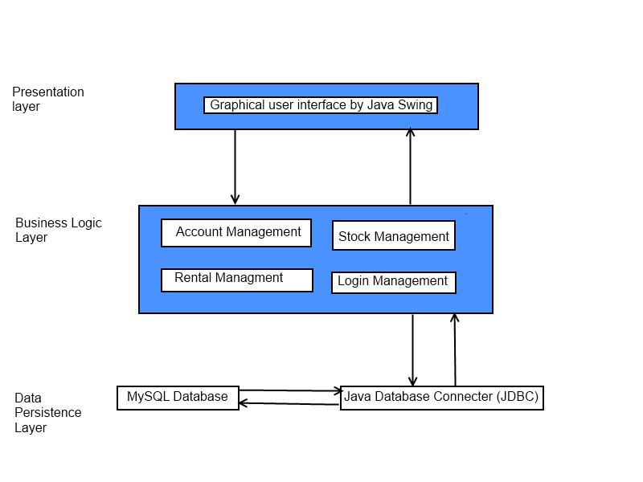

Detailed System Design

## Use case diagram

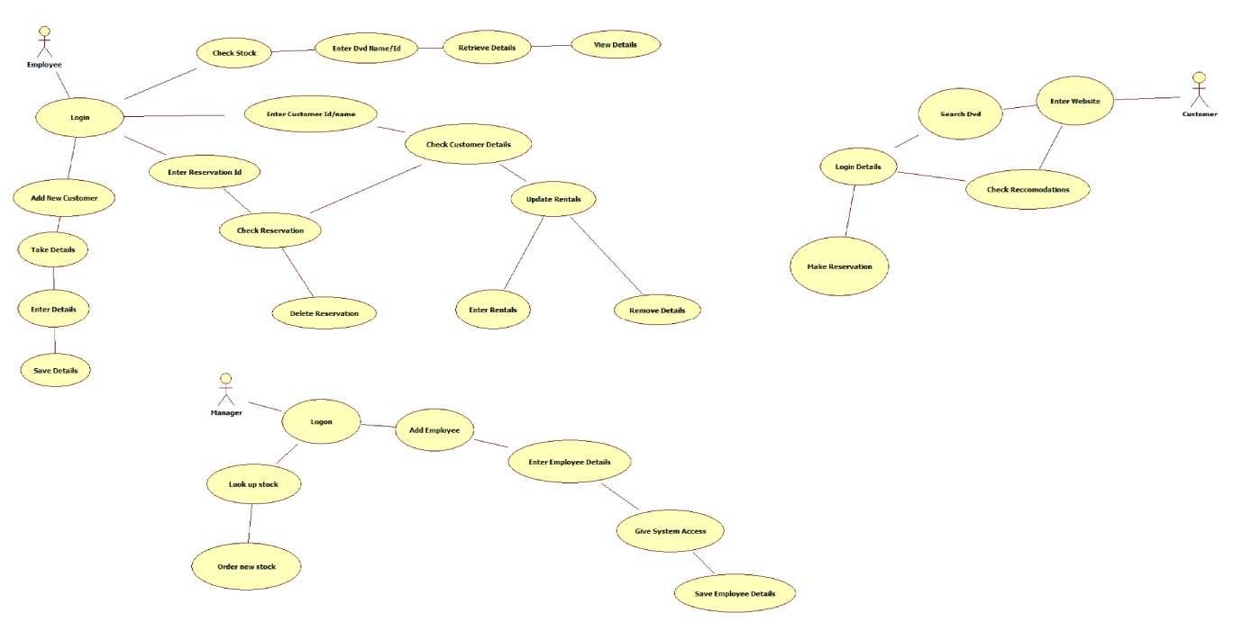

## Class diagram

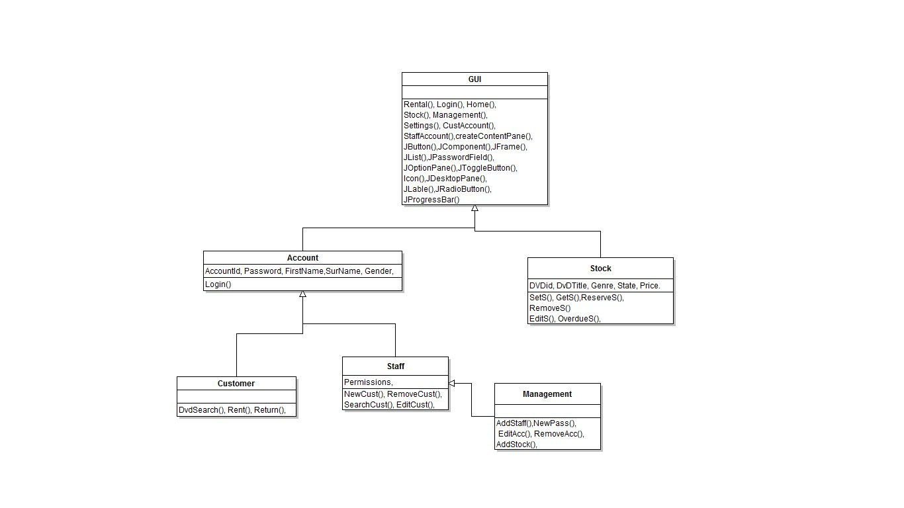

## Sequence diagram

## ERD

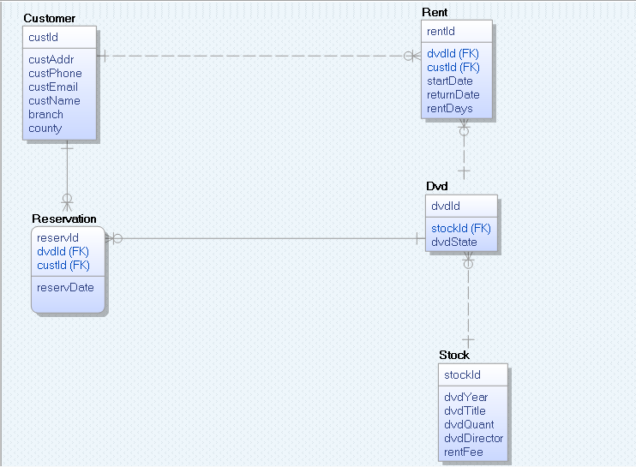

## State transition diagram 1

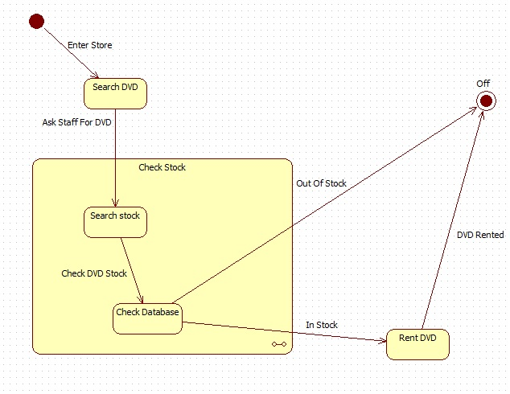

## State transition diagram 2

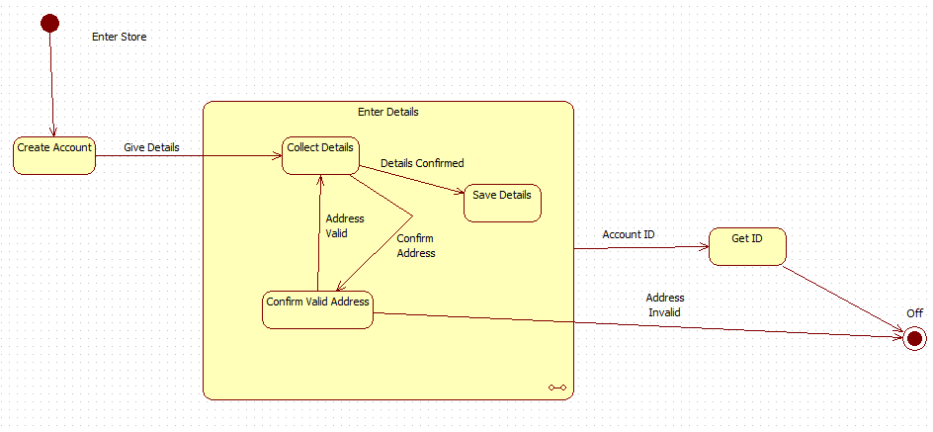

## Design

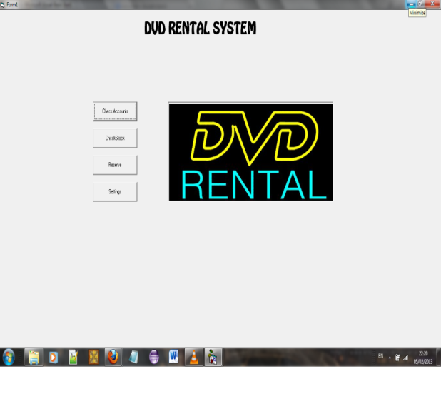 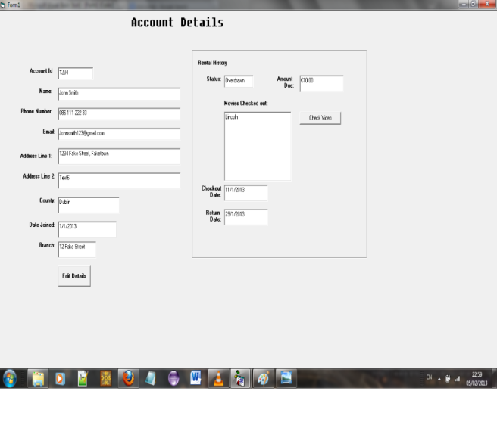

Design 1: Login Screen Design 2: Account Details Screen

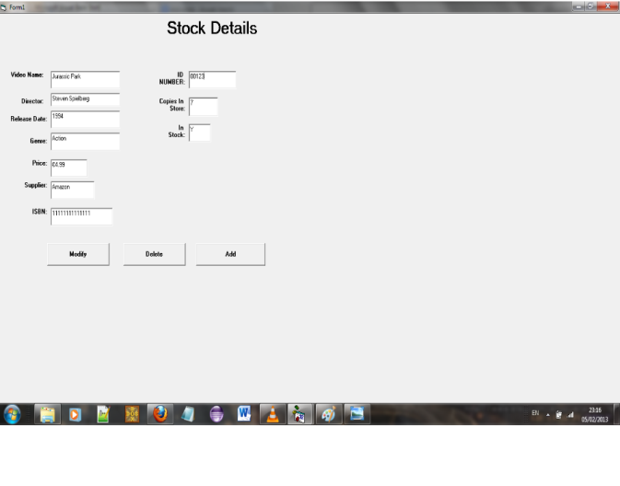 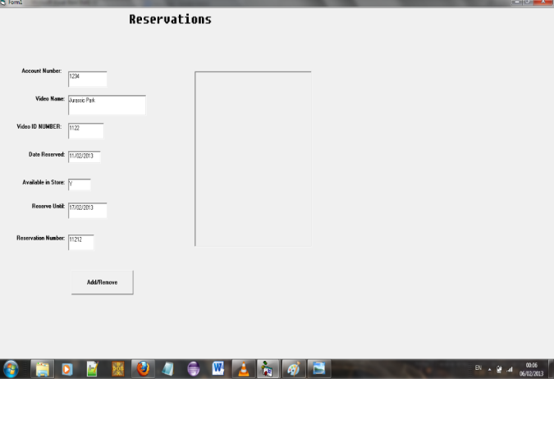

Design 1: Stock Details Screen Design 1: Reservation Screen

## Screen Shots

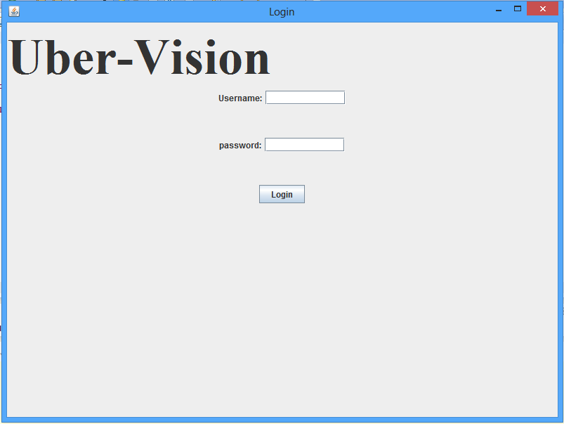 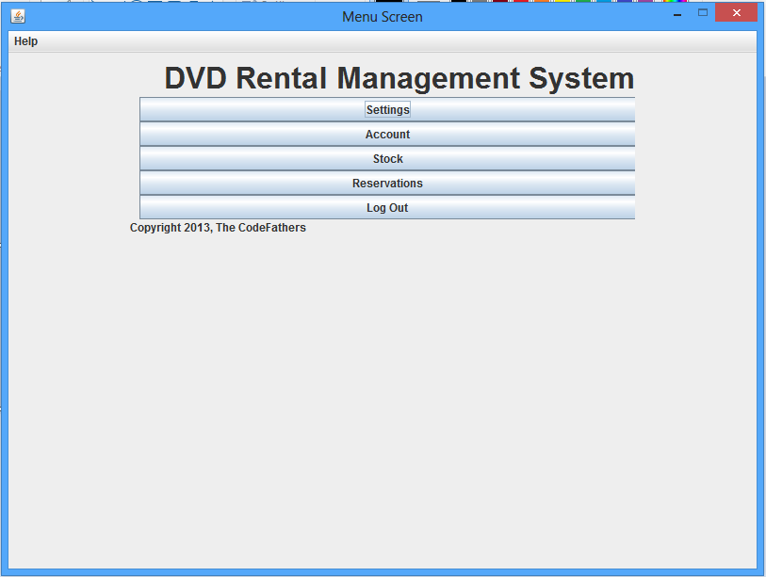

Figure 1: The menu Screen Figure 2: The login Screen

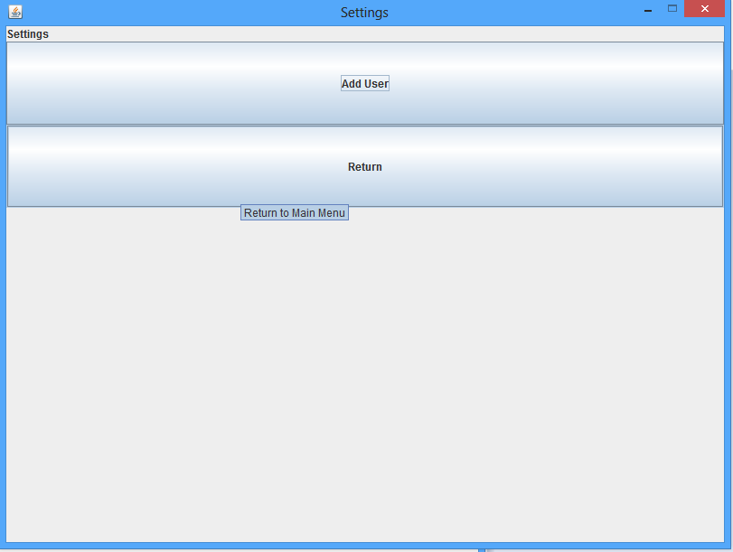 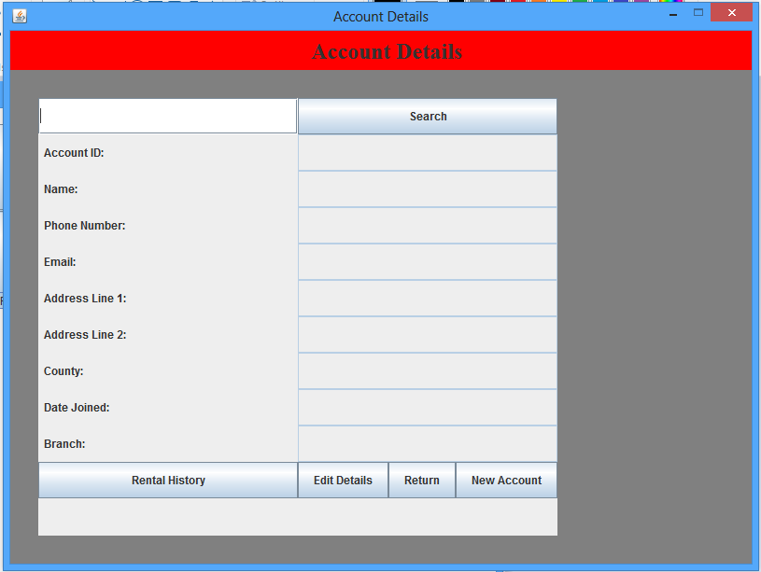

Figure 3: Setting screen Figure 4: Account Details Screen

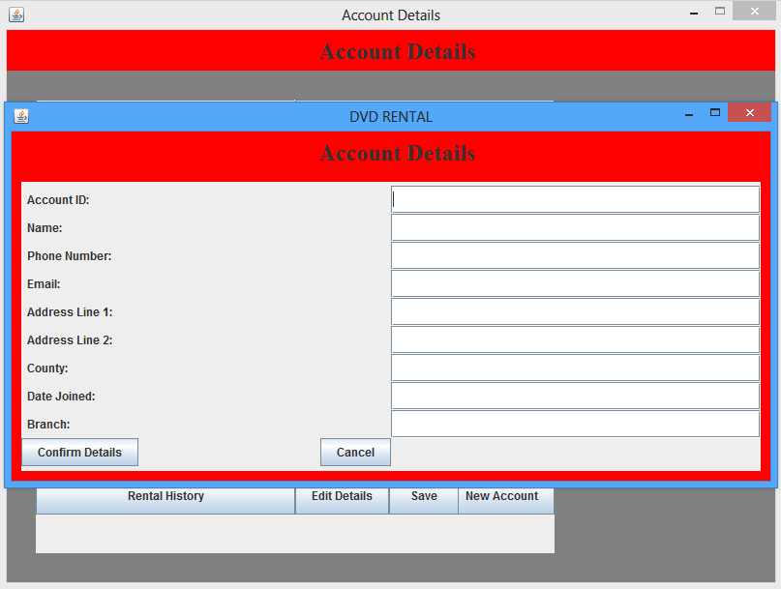 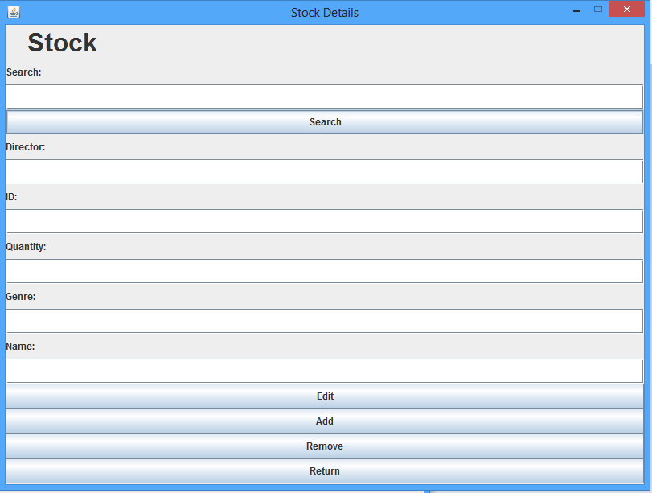

Figure 5: New Account Screen Figure 6: Stock Details Screen

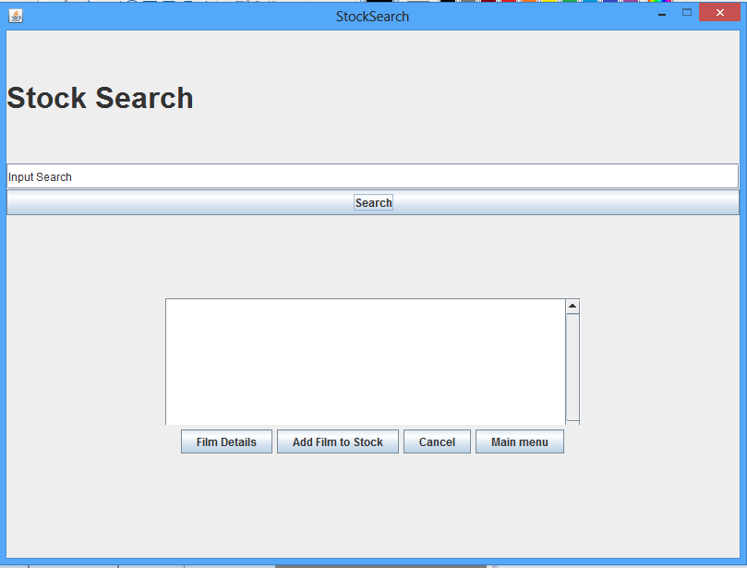 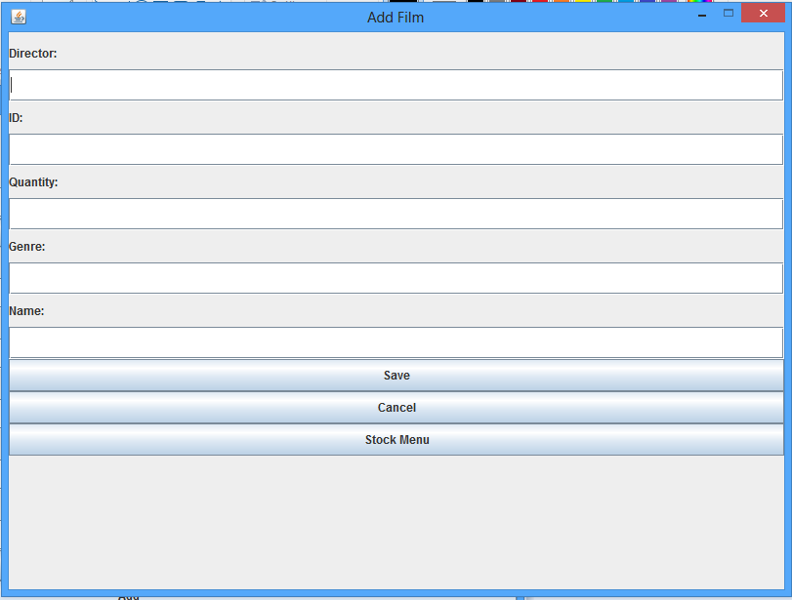

Figure 6: Stock Search Screen Figure 7: Add Film Screen

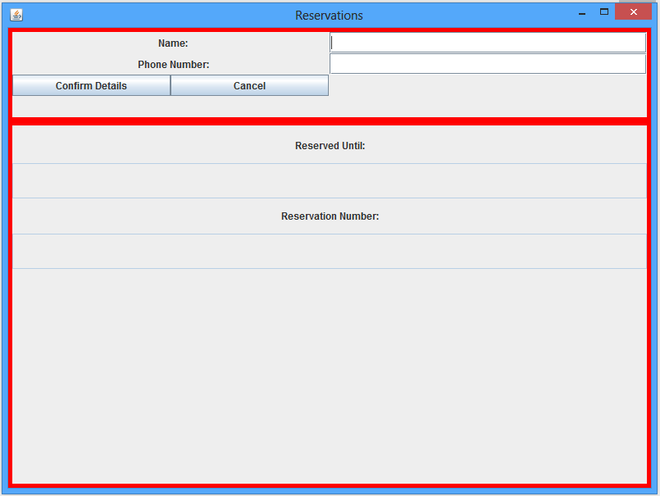 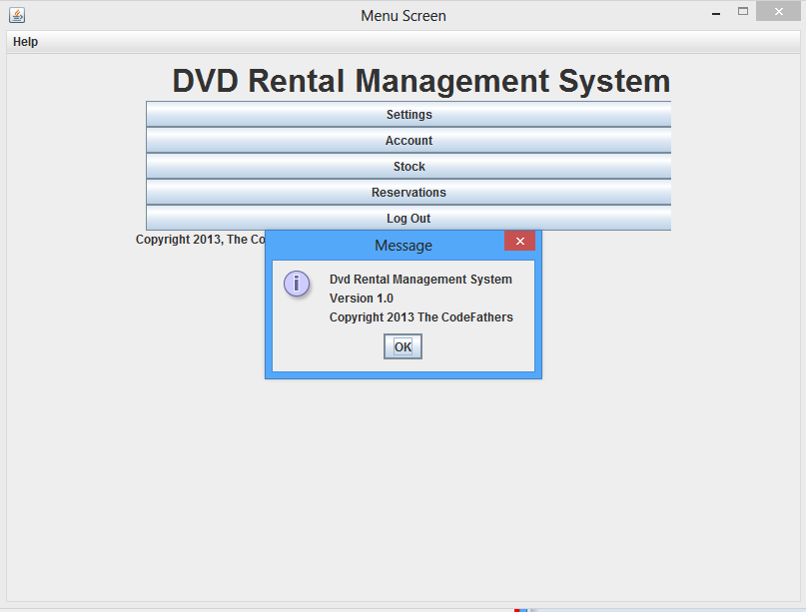

Figure 8: Reservation Screen Figure 9: About Screen

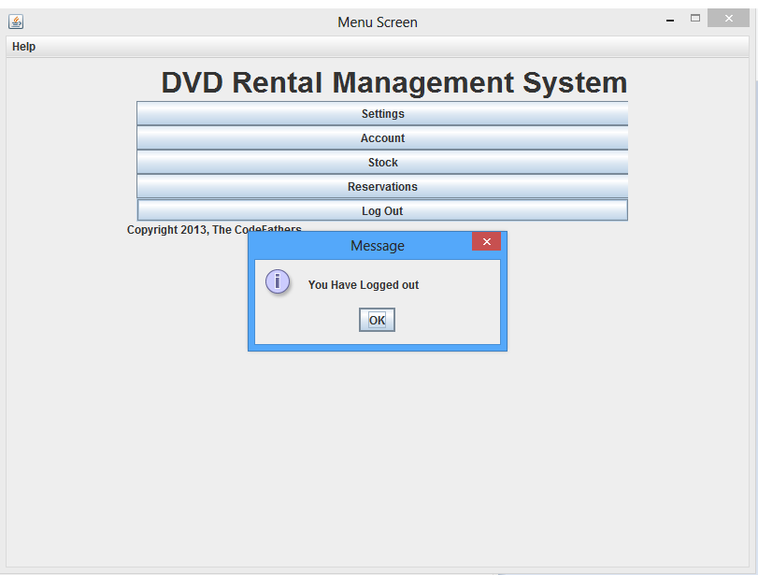

Figure 10: Login Out Screen

## Related Documents

|  |  |  |  |  |  |  |  |  |  |  |  |  |  |  |  |
| --- | --- | --- | --- | --- | --- | --- | --- | --- | --- | --- | --- | --- | --- | --- | --- |
| |  |  |  | | --- | --- | --- | | **Document Title** | **Author(s)** | **Description** | | Design Document | Paul | This is the Document that holds all the designs or any changes that have been made | | Test Plan | Dennis | This is the test plan we are using. It holds what plans we are using as well as test strategies. | | Minutes/Agenda | All | The minutes and must important points of discussed in the meetings | | User Manual | Dennis | This is a description on how to use our system | |